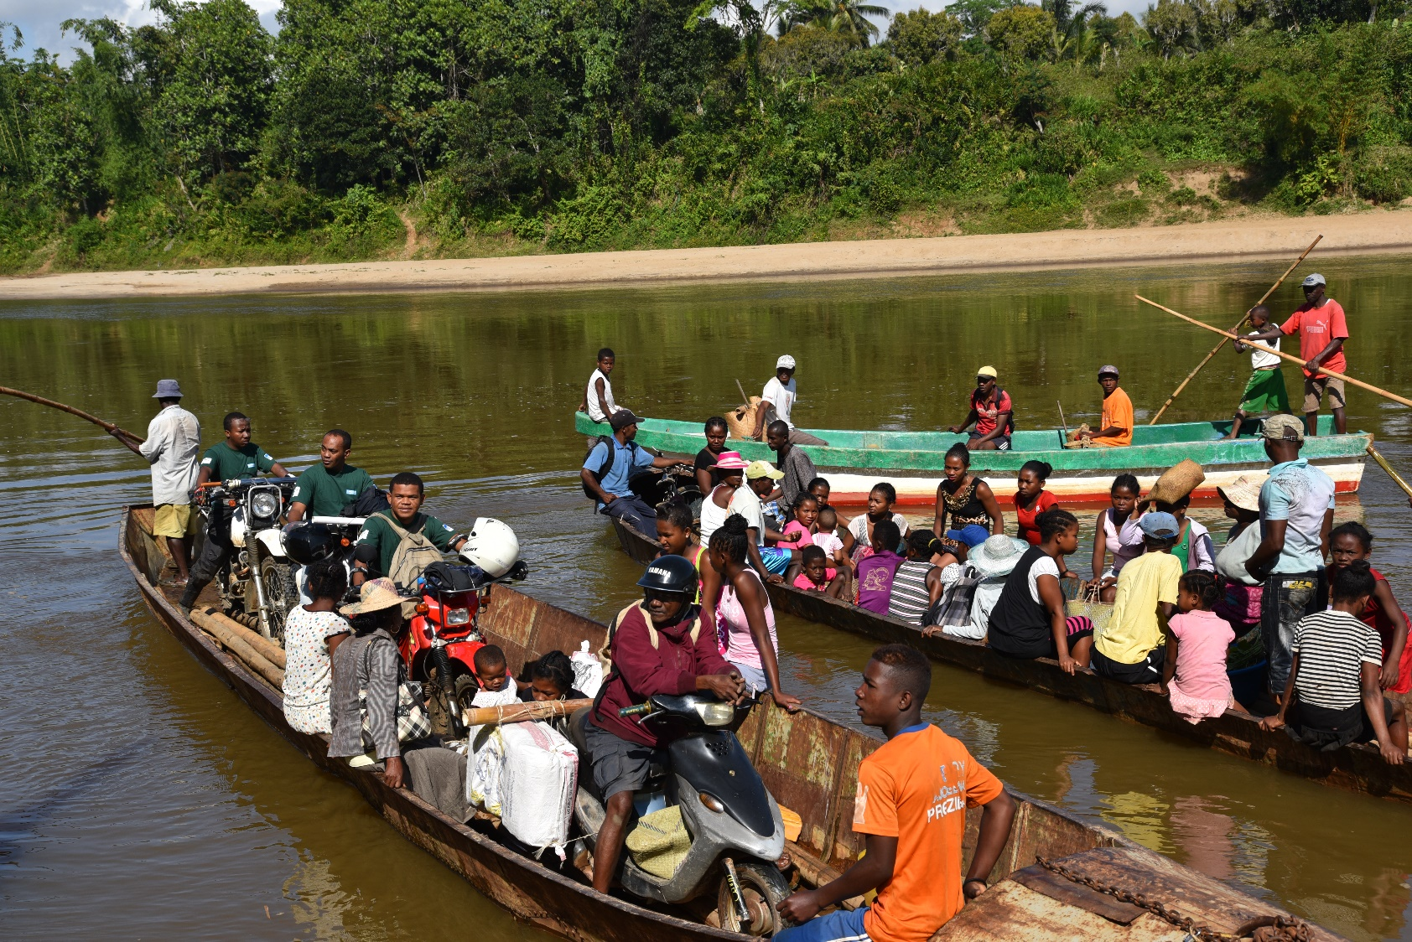

Country card
Madagascar 2021
HI’s team and where we work
HI’s programme in Madagascar has 163 staff members
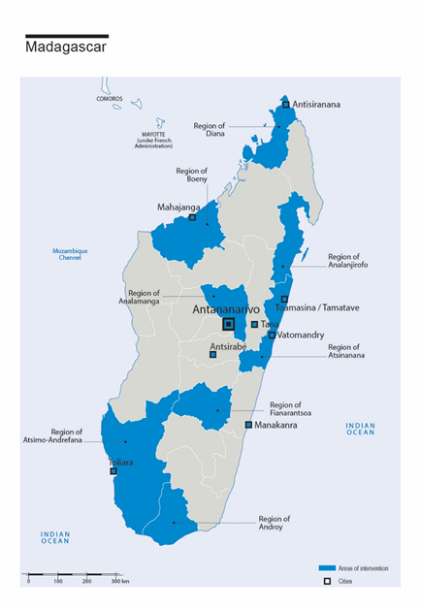
General country data
a. General data
Country | Madagascar | Mozambique | France
Population | 25,674,196 | 31,255,435 | 67,391,582
IHDI | 0.528 | 0.46 | 0.90
Gender development index | 0.952 | 0.912 | 0.987
Maternal mortality | 335 | 289 | 8
GINI index | 42.6 | 54 | 31.6
Population within the UNHCR mandate | 44 | 4,907 | 368,352
INFORM index | 5.2 | 6.7 | 2.2
Fragile States Index | 79.53 | 91.69 | 30.48
Public Social Protection | 0.7 | N/C | 31.7
Official development assistance received | 1,200 | 2226.8

b. Humanitarian law instruments ratified by the country
Humanitarian law instruments | Status
Mine Ban Treaty | Ratified on 16/09/1999
Convention on Cluster Munitions | Ratified on 03/12/2008
Convention on the Rights of Persons with Disabilities | Ratified on 12/05/2015

c. Geopolitical analysis
- Social, cultural and demographic context
A national census was taken in 2018 and the results were published in 2020. The previous census was taken in 1993. Madagascar has an annual population growth rate of 3.01%. A total of 80.7% of the population lives in rural areas where 85% of people live below the poverty line. Some 64% of the population is under the age of 25. Average life expectancy at birth is 67.64 years: 69.72 years for women and 65.76 years for men. The average household is made up of 4.3 people.

- Political situation
After a turbulent election, Andry Rajoelina assumed the presidency in 2018. He was also president during the transition to democracy, from 2009 to 2014. The next elections will be held in 2023.

Current policies aim to strengthen the economy by creating conditions favourable to business, international trade and direct foreign investment. Rajoelina has also promised to invest in education and, to a lesser extent, in public safety. He was actively involved in the response to the Covid pandemic.

- Economic situation
Some 74.3% of the population lives in extreme poverty ($1.90 per day), according to UNICEF. According to the World Bank, Madagascar is the fourth poorest country in the world in terms of per capita wealth. However, GDP increased by 4.8% in 2019, compared to 3.9% in 2017. According to the IMF, public and publicly guaranteed external debt (PPG) remains sustainable, with “moderate” external debt overhang. Inflation stabilised below 6% in 2019. However, the Covid-19 crisis will have a serious economic, social and budgetary impact: it will disrupt international trade and travel, and lockdown measures are expected to cause a sharp decline in business activity, with GDP expected to drop to 1.2, according to the World Bank. Vulnerable people will be particularly exposed to economic hardship and poverty traps. The collapse in tax revenues and expenditure related to the health crisis will increase the budget deficit, causing a sudden increase in financing needs.
As a result of the economic crisis caused by COVID-19, between 475,000 and 2.3 million more Madagascans may soon be living below the monetary poverty threshold.

Summary of HI’s work in the country

In 2017, HI celebrated 30 years of work in Madagascar, a period that can be divided into five activity phases:
- 1987 to 1996: rehabilitation actions only
- 1996 to 2005: Action “Nord Sud” period and work on structuring the non-profit sector
- 2006 to 2014: renewed focus on disability
- 2015-2019: MYOP¹(Multi-Year Operational Framework): extending our work to cover new fields and people who take part in our projects
- 2020: new country strategy 2020-2023

Current projects
Sectors where HI implements projects, focusing on beneficiaries and partners

Main sectors | Project goals in the sector | Main activities | Beneficiaries | Beneficiaries at the end of the project | Partners | Location | Project start and end date and funding bodies
Protection and Risk Reduction/  Natural disaster risk reduction and adaptation to climate change | Vonona  Early warning, disaster preparedness, rapid emergency response and support to COVID-19 vaccination campaigns in the west of the country | - Provide support to RDM (risk and disaster management) committees  - Build the capacities of the most vulnerable households to better cope with disasters through early warning systems  - Build the disaster risk reduction capacities of students and the education community  - Provide rapid response to the immediate and vital needs of the disaster-affected population  - Develop an emergency pool for rehabilitation and MHPSS |  | 754,985 people affected by climate disasters | BNGRC, ACF,  Save the Children  SIF,  Croix Rouge Luxembourgeoise, Helvetas | Boeny  Diana | July 2021 - June 2023  Funded by:  ECHO
Protection and Risk Reduction/  Natural disaster risk reduction and adaptation to climate change | Miaro  Help improve the resilience of people and institutions in the regions where we work  Build the preparedness and response capacities of institutions and populations | - Provide support to RDM (risk and disaster management) committees  - Build the capacities of the most vulnerable households to better cope with disasters through early warning systems  - Build the inclusive disaster risk reduction (IDRR) capacities of students and the education community  - Provide rapid response to the immediate and vital needs of the disaster-affected population |  | - 300 vulnerable households  - 900 children  - 600 members of Savings and Loans Village Organisations (AVECs)  - 400 members of the education community | Care  BNGRC  MEN | Regions: Boeny  Diana | July 2019 to October 2021  Funded by:  ECHO
Protection and Risk Reduction/  Natural disaster risk reduction and adaptation to climate change | Parirac  Build climate hazards preparedness and response capacities based on an integrated and inclusive multi-sector approach in the coastal zone of the Atsimo Andrefana region.  IRDM Inclusion Technical Assistance Project | - Participatory community-based vulnerability analysis in 133 Fokontany where we work  - Implement and operationalise the RDM Committees and Early Warning System  - Support beneficiary communities to develop contingency plans & simulation exercises  - Preposition regional contingency stock  - Train teachers and parents  - 2.4 Rehabilitation and strengthening of water, sanitation and hygiene (WASH) facilities in schools and reception facilities  - Development of an operational manual for emergency humanitarian response (cyclone or flood response) based on cash transfers  - Activate the Crisis Modifier in case of emergency |  | - 50 committee members  - 3,075 for 116 local rescue teams  - Teachers in 124 schools, or 2,640 people  - 22 people in institutional roles  - 750 adults from parent associations  - 20,000 disaster-affected people (CM framework) | ACF (lead),  Welt Hunger Hilfe (WHH)  Secours Islamique France (SIF) | Atsimo Andrefana Region | May 2020 - June 2022  Funded by:  ECHO
Social & Inclusion /  Educational services | Manonga  Inclusive Education (IE) and Social and Economic Inclusion:  Develop and implement IE along the "education-training" continuum to promote equal opportunities for young people with disabilities to succeed throughout their educational and learning careers  Model a system that contributes to the general education continuum and vocational training | - Assess access by young people with disabilities to secondary education and vocational training  - Assess growth sectors  - Develop inclusive education provision for secondary education and vocational training  - Facilities adjustment and building accessibility support  - Implement a personalised social support mechanism for young people with disabilities  - Build synergies between actors and advocacy and adaptation of public policies  - Raise the awareness of the capacities of people with disabilities in companies | N/A | - 28 primary schools  - 6 colleges  - 3 vocational training centres  - 16 DPDs  - 3,900 people benefiting from awareness raising  - 60 vocational training actors benefiting from awareness-raising | Min. National Education  Fanarenana | Region:  Atsinanana | January 2018 - December 2021  Funded by:  AFD
Health & prevention/  Non-communicable diseases /  Mental health and psychosocial support | Anjaratasara Phase II  Ensure the integrated management of people with epilepsy guaranteed in the community and at each level of the health pyramid, improve the social involvement of people and the inclusion of children with epilepsy in schools | - Build the skills of health workers  - Strengthen the community referral system  - Create or revitalise national organisations for people with epilepsy  - Provide psychosocial support to people with health problems and their families  - Include and detect epilepsy during school medical visits and support the inclusion of epileptic children in schools  - Raise awareness of the public and actors on epilepsy and the rights of people with epilepsy  - Raise awareness of mutual health insurance and other financial mechanisms for vulnerable people in the management of epilepsy | N/A | 400 people with epilepsy  20 doctors and  20 paramedical staff | Ministry of Public Health | Regions:  Analanjirofo  Boeny | January 2020 - December 2022  Funded by:  UCB
Health and Prevention/  Mental health and psychosocial support | Hifali  Develop and implement a community-based prevention and response strategy to improve the mental health of people in psychosocial distress and/or suffering from mental health disorders | - Implement a socio-anthropological study on mental health (MH) community representations, perceptions and practices  - Help the Ministry of Health develop a MH strategic plan  - Rehabilitate health facilities  - Coordinate MH and advocacy actors to advance the rights of people with MH disorders  - Build the capacities of health staff  - Raise the awareness of “tobys" and traditional practitioners on referrals to health facilities  - Strengthen the MH component of basic social-work training  - Implement a community mutual-support network and establishing an organisation of MH users |  | - 810 people with health problems  - 12 Min health technical managers  - 62 mental health professionals  - 164 community officers  - 98 traditional healers  - 190 MH facilities/actors  - 100 members of the DPD | Ministry of Public Health | Region:  Boeny | January 2018 - December 2021  Funded by:  AFD
Health & prevention/  Mental health and psychosocial support | Miarina  Improve the overall medical care of prisoners with tuberculosis and/or HIV in prison and on release  HI will take charge of the psychosocial component with the following objectives: develop and test a comprehensive psychosocial support mechanism in prisons | - Set up a reception workshop  - Set up a complaints management system  - Train prison actors in psychosocial support  - Support/help actors to provide psychosocial support and life plans  - Organise sports and socio-educational activities | N/A | 3 prisons  > 80% of detainees assessed | Ministry of Public Health  Ministry of Justice  Ministry of Population  IPM  EKAR  PPI | Project-based work:  Tana  Mahajanga  Tamatave  Manakanra  HI’s work:  Tana  Mahajanga  Tamatave | October 2019 - September 2022  Funded by:  Expertise France  Initiative 5%
Health & prevention/  Mother, neonatal and infant health | Casimir  Improve access to mother and child health (MCH) and the MCH-rehabilitation services care continuum | - KAP study and mapping of health actors and services  - Review training curricula and training of health and rehabilitation professionals  - Train social workers to prevent risk factors, detect impairments and refer people to health facilities  - Provide community-based rehabilitation training  - Implement the minimum package of mother and child health activities  - Design and implement a financial access support mechanism  - Community and DPO awareness | N/A | - 154 health professionals trained  - 20 social workers  - 1,620 users of local rehabilitation services  - 2,580 beneficiaries of a minimum package of mother and child health activities  - 600 women and/or children with access to funding systems  - 19,200 young people made aware of health issues | Ministry of Public Health,  Ministry of Population, Social Welfare and the Advancement of Women | Regions:  Atsimo Andrefana Region | January 2018 - December 2022  Funded by:  MAE Lux  Fondation Roi Baudoin
Health & prevention/  Sexual and Reproductive Health (SRH) | WISH2Action  Improve access of vulnerable women to sexual and reproductive health  HI’s specific role is to ensure people with disabilities and their needs are taken into account | - Develop and implement an impact strategy for public policies and help the Ministry of Public Health to achieve its goals  - Develop and implement a public communication and information strategy on sexual and reproductive health services and changing beliefs and practices  - Deploy paramedical staff for at-home services  - Strength local follow-up care and rehabilitation services via Marie Stopes Madagascar centres  - Set up mobile teams to offer services in the most isolated areas | N/A |  | Marie Stopes Madagascar (leader)  Options  DMI | National level | September 2018 - December 2022  Funded by:  Foreign, Commonwealth & Development Department (FCDO)  Formerly DFID
Social & Inclusion /  Social service  Advocacy:  Inclusive development | Mahatsangy  Support to the disability movement:  Strengthen organisations working with and for people with disabilities to empower them | - Implement organisational self-assessment for two organisations  - Implement a co-funding mechanism and advisory support for partner organisation projects  - Inter-organisational meetings, practices lesson-learning  - Map organisation network coordination spaces and an impact plan | 7 partner organisations | 7 partner organisations | UNAHM  Orchidées blanches  Fanarenana  FAAM  Ephata  AJFACE | Tananarive  Antsirabe  Fianarantsoa  Diego Suàrez | January 2019 - December 2021  Funded by:  DCI Monaco
Social & Inclusion /  Social services  Advocacy /  Inclusive development | Famaha (HELASIAM)  Advance the rights of people with disabilities and improve their quality of life through more inclusive services | - Build the capacities of CSOs  - Build the momentum of the disability observatory  - Implement advocacy actions  - Set up multi-actor committees in the region  - Contribute to the national disability inclusion plan (PNIH)  - Membership of InStat WG  - Inclusive education actions and mental health | N/A | N/A | CONAMEPT  COPH  PFPH  AUM  AFHAM  UNAPHAAM | Diana, Atsinanana, Boeny, Analamanga | December 2020 - December 2022  Funded by:  NORAD
Advocacy /  Inclusive development  Protection and Risk Reduction/  Natural disaster risk reduction and adaptation to climate change | Maharo  Mainstream disability in development and civil society action  Improve food security for vulnerable households and continued crop production for drought-affected households  HI’s role is to ensure people with disabilities and their needs are taken into account. | - Provide essential inputs and technical support to farmers and fishermen  - Promote adaptation and mitigation for sustainable food security and resilience | N/A | 20,000 households or 80,000 people | CRS (lead) | Androy region | September 2019 - September 2024  Funded by:  USAID, CRS
Emergency/  Health & prevention/  Rehabilitation services /  Protection and Risk Reduction/  Natural disaster risk reduction and adaptation to climate change | Tialongo  Supply emergency food aid to people with disabilities and their households in the region of Atsimo Andrefana to reduce the nutritional risks from drought in the Grand Sud region and assist medical services in reducing disability in children aged 0 to 5 suffering from malnutrition or under-nutrition | - Provide financial support or support in kind to beneficiaries  - Implement physiotherapy stimulation actions |  | - 1,036 children with disabilities and their families  - 110 healthcare staff in health centres  - 800 children aged 0 to 5 suffering from malnutrition and their parents | N/A | Atsimo Andrefana | April 2021 to July 2022  Funded by:  French Embassy
Emergency/  Social & Inclusion /  Economic services  Health & Prevention / Severe or chronic pandemics | Mitehafa  Help adapt behaviour in response to the pandemic while building the response and preparedness capacities and economic and psychological resilience of affected people, especially those with special needs | - Information and awareness-raising to change behaviour in response to the pandemic, mitigate stress factors, and reduce the stigma and discrimination experienced by target audiences  - Build the capacity of actors to care manage the psychological distress caused by the pandemic for target audiences  - Strengthen the resilience of vulnerable households by supporting the "Loharano" response and taking into account people with special needs  - Anticipate and prepare for a second COVID-19 crisis  - Awareness-raising, supplies of equipment in schools | N/A | - 200,000 people covered by awareness-raising, targeting people with special needs in particular  - Some 900 pre-targeted people including intra-hospital medical and non-medical staff, as well as Covid-19 patients and their families  - Some 3,000 vulnerable households or 12,600 people provided with social and economic support  - Actors in Covid-19 response | Covid-19 Operations Coordination Centre  Douleurs Sans Frontières  SOS Villages d’enfants  Ordre des Psychologues  Disabled people’s organisations  Civil society organisations | Analamanga  Analanjirofo  Atsinanana  Atsimo Andrefana  Anosy  Androy | May 2020 - December 2021  Funded by:  European Union  AFD

Donors

Expertise France  Initiative 5% | DCI Monaco  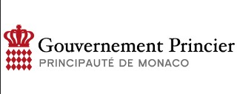 | AFD  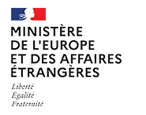
MAE Luxembourg  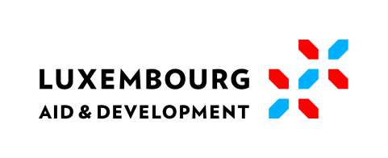 | FCDO  Foreign, Commonwealth & Development Department  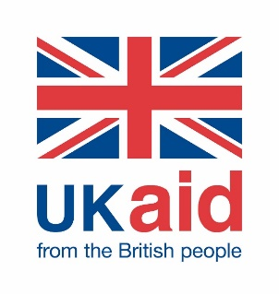 | USAID  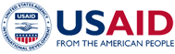
ECHO / EU  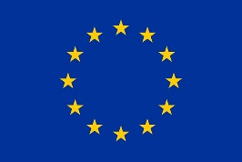 | French Embassy | Fondation Roi Baudoin  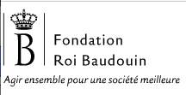
NORAD |  | UCB

https://www.instat.mg/p/resultats-definitifs-du-rgph-3-2018-troisieme-recensement-general-de-la-population-et-de-lhabitation
https://www.banquemondiale.org/fr/country/madagascar/overview#1

